Internal verification of assessment decisions – BTEC Higher Nationals (RQF)

INTERNAL VERIFICATION – ASSESSMENT DECISIONS (Single Student)
Programme Title:
Unit Number and Title:
Assessor Name: |  |  |  | Internal Verifier Name:
Assignment title:
Name of student | Submission Type  (First, Resubmission, Retake) | Grade the Assessor has awarded. | Assessment Decision Accurate (Y/N)  (Resubmission and retake must be capped at a Pass) | List the learning outcomes and grading criteria where inaccurate decisions have been made |  | State why the assessment decision is inaccurate.  *If an inaccurate decision is recorded the Internal Verifier must recommend actions detailing the issues to be addressed. The Assessor and the Internal Verifier must then confirm that the action has been undertaken before assessment decisions are issued to the student.
INTERNAL VERIFIER CHECKLIST |  |  |  |  |  |  | Y/N
Has the student and the Assessor confirmed the authenticity of the evidence?
Is there evidence of collusion or plagiarism? The work submitted for assessment has been carried out without assistance other than that which is acceptable according to the rules of the specification. The evidence submitted for this assignment is student’s own. The student has clearly referenced any sources and any artificial intelligence (AI) tools used in the work.
Is the assessor feedback to the student appropriate and constructive to each student? Provide comments below.
- Points out strengths and areas for improvement.
- Linked to relevant learning outcomes and assessment criteria.
- Clear as to why the student did not achieve higher grades.
- Identify opportunities for improved performance in future assignments.
GENERAL COMMENTS
Any actions required must be reviewed across the whole cohort.
Action Required |  |  |  |  | Target Date for Completion |  |  | Date Action Completed
I confirm that the assessment decisions are accurate, there is no evidence of assessment malpractice and any action points have been addressed and completed in respect of the whole cohort. I declare the work submitted for assessment has been carried out without assistance other than that which is acceptable according to the rules of the specification. The evidence submitted for this assignment is student’s own. The student has clearly referenced any sources and any artificial intelligence (AI) tools used in the work.
Internal Verifier signature |  |  |  |  | Date
Assessor signature |  |  |  |  | Date

Higher Nationals - Summative Assignment Feedback Form

Student Name/ID
Unit Title | Discrete Maths
Assignment Number | Assignment 01 | Assessor
Submission Date |  | Date Received 1st submission
Re-submission Date |  | Date Received 2nd submission
Assessor Feedback:

*Please note that constructive and useful feedback should allow students to understand:

- Strengths of performance
- Limitations of performance
- Any improvements needed in future assessments

Feedback should be against the learning outcomes and assessment criteria to help students understand how these inform the process of judging the overall grade.

Feedback should give full guidance to the students on how they have met the learning outcomes and assessment criteria.
I certify that to the best of my knowledge the evidence submitted for this assignment is the student’s own. The student has clearly referenced any sources and any artificial intelligence (AI) tools used in the work. I have not solely used AI to grade the student’s work.

Grade: | Assessor Signature: |  | Date:
Resubmission Feedback:
*Please note resubmission feedback is focussed only on the resubmitted work
Grade: | Assessor Signature: |  | Date:
Internal Verifier’s Comments:
Signature & Date:

* Please note that grade decisions are provisional. They are only confirmed once internal and external moderation has taken place and grades decisions have been agreed at the assessment board.
Pearson Education 2016
Higher Education Qualifications
Internal Verification of Assignment Brief

Student Assessment Submission and Declaration

When submitting evidence for assessment, each student must sign a declaration confirming that the work is their own.

Student name:  MN. Sihanas |  | Assessor name:  Eng. A.L. Jubailah Begum
Issue date:  03.03.2025 | Submission date:  15.04.2025 |  | Submitted on:
Programme:
Pearson BTEC Higher Nationals in Computing
Unit: Discrete Maths
Assignment number and title: 1. Applications for sets, graph theory, Booleans & abstract algebra

Plagiarism
Plagiarism is a particular form of cheating. Plagiarism must be avoided at all costs and students who break the rules, however innocently, may be penalised. It is your responsibility to ensure that you understand correct referencing practices. As a university level student, you are expected to use appropriate references throughout and keep carefully detailed notes of all your sources of materials for material you have used in your work, including any material downloaded from the Internet. Please consult the relevant unit lecturer or your course tutor if you need any further advice.

Student Declaration

Student declaration
I certify that the assignment submission is entirely my own work and I fully understand the consequences of plagiarism. I declare that the work submitted for assessment has been carried out without assistance other than that which is acceptable according to the rules of the specification. I certify I have clearly referenced any sources and any artificial intelligence (AI) tools used in the work. I understand that making a false declaration is a form of malpractice.

Student signature:1030371@bcas.ac Date:2025.04.15

General Guidelines

- A Cover page or title page – You should always attach a title page to your assignment. Use previous page as your cover sheet and make sure all the details are accurately filled.
- Attach this brief as the first section of your assignment.
- All the assignments should be prepared using a word processing software.
- All the assignments should be printed on A4 sized papers. Use single side printing.
- Allow 1” for top, bottom, right margins and 1.25” for the left margin of each page.

Word Processing Rules

- The font size should be 11 points, and should be in the style of Arial.
- Use 1.5 line spacing. Left justify all paragraphs.
- Ensure that all the headings are consistent in terms of the font size and font style.
- Use footer function in the word processor to insert Your Name, Subject, Assignment No, and Page Number on each page. This is useful if individual sheets become detached for any reason.
- Use word processing application spell check and grammar check function to help editing your assignment.

Important Points

- It is strictly prohibited to use text boxes to add texts in the assignments, except for the compulsory information. eg: Figures, tables of comparison etc. Adding text boxes in the body except for the before mentioned compulsory information will result in rejection of your work.
- Avoid using page borders in your assignment body.
- Carefully check the hand in date and the instructions given in the assignment. Late submissions will not be accepted.
- Ensure that you give yourself enough time to complete the assignment by the due date.
- Excuses of any nature will not be accepted for failure to hand in the work on time.
- You must take responsibility for managing your own time effectively.
- If you are unable to hand in your assignment on time and have valid reasons such as illness, you may apply (in writing) for an extension.
- Failure to achieve at least PASS criteria will result in a REFERRAL grade.
- Non-submission of work without valid reasons will lead to an automatic RE FERRAL. You will then be asked to complete an alternative assignment.
- If you use other people’s work or ideas in your assignment, reference them properly using HARVARD referencing system to avoid plagiarism. You have to provide both in-text citation and a reference list.
- If you are proven to be guilty of plagiarism or any academic misconduct, your grade could be reduced to A REFERRAL or at worst you could be expelled from the course.

Unit 18: Discrete Maths
Assignment Brief
Programme Title | Pearson BTEC Higher Nationals in Computing
Student Name/ID Number
Unit Number and Title | Unit 18: Discrete Maths
Academic Year | 2025
Unit Tutor | Eng. A.L. Jubailah Begum
Assignment Title | Applications for sets, graph theory, Booleans & abstract algebra
Issue Date | 03.03.2025
Submission Date | 15.04.2025
Submission Format
The submission should be in the form of an individual report written in a concise, formal business style using single spacing and font size 12. You are required to make use of headings, paragraphs and subsections as appropriate, and all work must be supported with research and referenced using Harvard referencing system. Please also provide an end list of references using the Harvard referencing system.
The recommended word count is 5,000–5,500 words for the report excluding annexures, although you will not be penalised for exceeding the total word limit.

Unit Learning Outcomes
LO1. Examine set theory and functions applicable to software engineering.
LO2. Analyze mathematical structures of objects using graph theory.
LO3 Investigate solutions to problem situations using the application of Boolean algebra.
LO4. Explore applicable concepts within abstract algebra.

Transferable skills and competencies developed
Vocational scenario

You are assigned as a trainee in a software development center for a project and they want to check your knowledge in mathematics. The following questions are assigned to you; so that your supervisor can decide to which team you are suitable for.

Assignment activity and guidance
Q1)
i) Let A and B be two non-empty finite sets. If cardinalities of the sets A, B, and A ∩ B are 160, 50 and 25 respectively.
Find the cardinality of the set AUB.
If n (A - B) = 30, n (AUB) = 70 and n (A ∩ B) = 10, then find n(B).
If A, B and C are disjoint sets n(A) = 200, n(B) = 140 and n(C) = 55, find n (AUBUC).
Note: You can use either Venn diagrams or set formulas / properties for the answer.
ii) Let A and B be two non-empty finite sets. If cardinalities of the sets A, B, and A ∩ B are 360, 150 and 75 respectively.
Find the cardinality of the set AUB.
If n (A - B) = 50, n (AUB) = 170 and n (A ∩ B) = 20, then find n(B).
If A, B and C are disjoint sets n(A) = 800, n(B) = 340 and n(C) = 90, find n (AUBUC).
Note: You can use either Venn diagrams or set formulas / properties for the answer.

Q2) Find the inverse of the following functions.
i) f(x) = x + 60
ii) f(x) = 10 / (x+60)
iii) f(x) = (120-x) / 80
iv) f(x) = (x-5) / (x+5)
v) f(x) = x³ – 64

Q3) Model contextualised problems using trees, both quantitatively and qualitatively.

Q4) Access whether an Eulerian and Hamiltonian circuit exists in the below given undirected graphs.
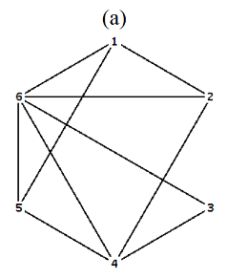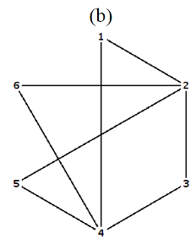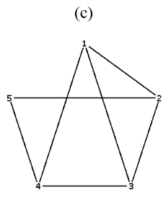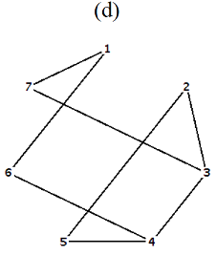

Q5)
i) Find the shortest path and shortest distance from a to z of the following graph.
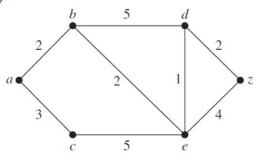
ii) Find the shortest path and shortest distance from s to t of the following graph.
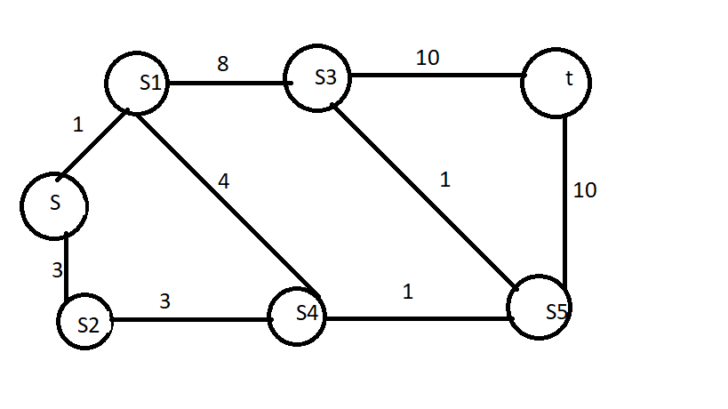
Q6) Find the final output equation for the below logic circuit and prepare the truth table for that final output equation.
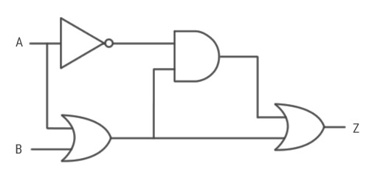

Q7)
Simplify below Boolean expressions.
- AB + A (B+C) + B (B+C)
- AB’ + A (B+C)’ + B (B+C)’
- (AB’ (C+BD) + A’B’) C
- A’BC + AB’C’ + A’B’C’ + AB’C + ABC

Q8)
Create a truth table for the following given scenario and find the final output equation for that truth table using SOP method. Then, draw a logic gate based digital circuit for that final output equation.
There is an electronic door system. That system has two sensors called A and B. If at least one of the following conditions is satisfied, then the door is opened.
- Sensor A is activated.
- Both sensor A and Sensor B are activated.
Construct the truth table for above scenario.
The active state of the sensors is represented using 1.
The inactive state of the sensors is represented using 0.
Door open state is represented using 1.
Door close state is represented using 0.

Q9)
Discuss a real-world binary problem in the application of Boolean algebra. Provide relevant diagrams.

Q10)
Colorize following provincial map of Sri Lanka using five-color theorem.
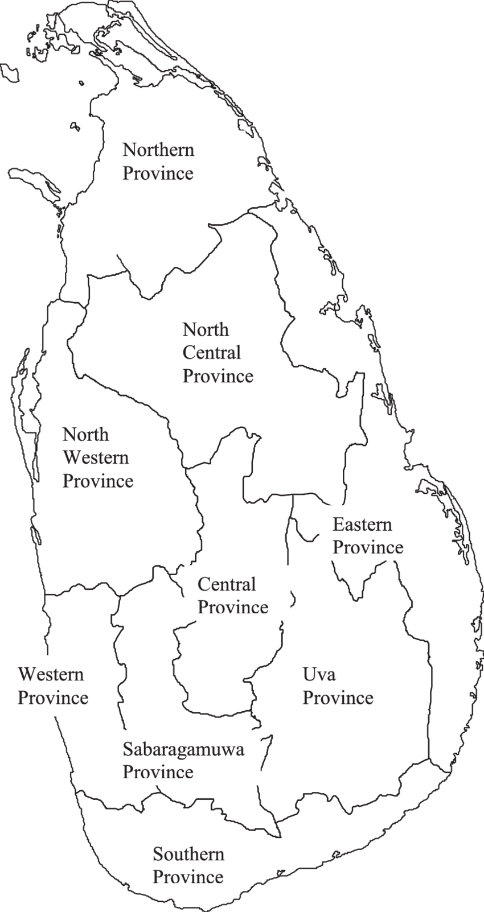

Q11)
When considering the set of all the natural numbers (ℕ), show whether the mathematical operations of addition, subtraction, multiplication and division are:
- Associative binary operation
- Commutative binary operation

Q12)
- Determine the order of a group and the order of a subgroup in the group G=Z₆ (the integers modulo 6 under addition).
- Validate that the set of non-zero real numbers with the operation of multiplication is a commutative group.

Q13)

You are required to prepare a 15-minutes presentation aimed towards new students engaged under a technology company’s graduate scheme.

Your presentation will include evidence of:
An explanation that adequately explains why group theory is taught to computing students.

Recommended Resources

Please note that the resources listed are examples for you to use as a starting point in your research – the list is not definitive.

Learning Outcomes and Assessment Criteria
Pass | Merit | Distinction
LO1 Examine set theory and functions applicable to software engineering |  | D1 Formulate corresponding proof principles to prove properties about defined sets.
P1 Perform algebraic set operations in a formulated mathematical problem.  P2 Determine the cardinality of a given bag (multiset). | M1 Determine the inverse of a function using appropriate mathematical techniques.
LO2 Analyse mathematical structures of objects using graph theory |  | D2 Construct a proof of the Five Colour Theorem.
P3 Model contextualized problems using trees, both quantitatively and qualitatively.  P4 Use Dijkstra's algorithm to find a shortest path spanning tree in a graph. | M2 Assess whether an Eulerian and Hamiltonian circuit exists in an undirected graph. | D2 Construct a proof of the Five Colour Theorem.
LO3 Investigate solutions to problem situations using the application of Boolean algebra |  | D3 Design a complex system using logic gates.
P5 Diagram a binary problem in the application of Boolean Algebra.  P6 Produce a truth table and its corresponding Boolean equation from an applicable scenario. | M3 Simplify a Boolean equation using algebraic methods. | D3 Design a complex system using logic gates.
LO4 Explore applicable concepts within abstract algebra |  | D4 Prepare a presentation that explains an application of group theory relevant to your course of study.
P7 Describe the distinguishing characteristics of different binary operations that are performed on the same set.  P8 Determine the order of a group and the order of a subgroup in given examples. | M4 Validate whether a given set with a binary operation is indeed a group.

